TOPIC 1: QUADRATIC EQUATION
Quadratic equation is a type of equation where the highest power on the variable is 2.
We have looked extensively at the concepts of simple equations. We now seek to expand that concept into variables operating in the square power.
Objective:
At the end of the session, the student will be able to:
- Solve quadratic equations by factorization.
- Apply the formula method to solving quadratic equations
- Apply the graphical method to solving quadratic equations.
Generally, a quadratic equation can be mathematically expressed as
$$ax^{2}+bx+c=0 \left(i\right)$$
In which, x is the independent variable being calculated, and a,b and c are usually fixed or constant values.
Solving quadratic equations by factorization
Consider the general form,
$$ax^{2}+bx+c=0 \left(i\right)$$
In order to factorize (i), we check two major steps.
Step 1: find ac
Step 2: find the integer factors of ac, say m and n, such that m+n=b and mn=ac
Once steps 1 and 2 are both satisfied, then (i) is factorize as
$$ax^{2}+bx+c=ax^{2}+mx+nx+c=0$$
Example:
- Solve $x^{2}-2x-15=0 by factorization$
By comparison, a=1 b= -2 c= -15
Step 1: ac = -15
Step 2:
m | n | m + n = -2 | a c= -15
1 | -15 | 1-15= -14
-1 | 15 | -1 +15 += 14
3 | -5 | 3-5 = -2 | → both checked
-3 | 5 | -3 + 5 = 2
Therefore, m= 3 n= -5
Thus,
$$x^{2}-2x-15= x^{2}-3x-15=0$$
=x(x+3) -5(x+3)=0
=(x+3)(x-5)=0
=x -5=0; x+3=0
=x=5 and x= -3
- Solve $x^{2}-10x-25=0 by factorization$
a=1 b= -10 c=25
Step i: ac=25

m | n | m + n=b
1 | 25 | 26
-1 | -25 | -26
5 | 5 | 10
-5 | -5 | -10
m = -5 n= -5
$x^{2}-10x-25= x^{2}-5x-5x+25=$ 0
= x(x-5) -5(x-5)=0
= (x-5)(x-5)=0
=x-5 =0; x-5=0
x=5 ; x=5
x=5 twice
Solving Quadratic Equation By Formula Method
Consider the general form of the quadratic equation,
${ax}^{2}+bx+c=0$
Then, x is the root of the equation if
x = $\frac{-b± \sqrt{b^{2}}-4ac}{2a} \left(ii\right)$
(ii) is known as the Quadratic Formula

Example:
- Solve for x in $x^{2}-2x-15=0$
a = 1 b=-2 c= -15
x = $\frac{-b± \sqrt{b^{2}}-4ac}{2a}$
x = $\frac{-(-2)± \sqrt{{\left(-2\right)}^{2}}-4(1)(-15)}{2(1)}$
x = $\frac{2± \sqrt{4+60}}{2}$
x= $\frac{2± \sqrt{64}}{2}$
x= $\frac{2+ \sqrt{8}}{2} or \frac{2-\sqrt{8}}{2}$
x= 5 or x= -3
- Solve for x in $-2x^{2}-x+3=0$
a = -2 b= -1 c=3
x= $\frac{-b± \sqrt{b^{2}}-4ac}{2a}$
x=$\frac{-(-1)± \sqrt{{(-1)}^{2}}-4(-2)(3)}{2(-2)}$
x= = $\frac{1± \sqrt{1+24}}{-4}$
x= $\frac{1± \sqrt{25}}{-4}$
x= $\frac{1+\sqrt{5}}{-4} or \frac{1-\sqrt{5}}{-4}$
x= $\frac{6}{-4} or x=\frac{-4}{-4}$
x= $\frac{-3}{2} or x=1$

Solving Quadratic Equation By Graphical Method:
In this case, we consider range of values for the independent variable, x, and seek to find the values of x for which the formed curve intercepts the x-axis {i.e. ($x_{1, }0) and (x_{2, }0)\}$.
Example:
Solve the equation $x^{2}+x-3=0$by drawing its graph for $-3≤x≤2$. First, we remote the quadratic equation in terms of the dependent variable.
Let y be the dependent variable,
y = $x^{2}+x-3$
We seek to find $x_{1 }$and $x_{2 }$such that y=0 at those two points.
Next, we set up the value table, based on the range for x.
 | x | -3 | -2 | -1 | 0 | 1 | 2
$$x^{2}+x-3$$ | y | 3 | -1 | -3 | -3 | -1 | 3
Next, we plot these pair of points on the graph, picking a suitable scaling value. In this case,
x-axis: 2cm to 1 unit
y-axis: 2cm to 1 unit
Next, we read said graph to seek out ($x_{1 , }0) and (x_{2 , }0)$
We find that $x_{1 }$= 1.3 and $x_{2 }$= -2.3
NOTES ON QUADRATIC GRAPHS
Given y = ${ax}^{2}+bx+c$
- If a$>0, then the graph is U-shaped or upward curved$
- If a$<0, then the graph is a inverted U \left(or an n\right)or downward curved.$
- C refers to the value of the y-intercept i.e.(o,c)

DRILL
- Solve for d in $d^{2}+d-6=0$by factorization
- Factorize completely and find t in 2$t^{2}+t-15=0$
- Solve 4$x^{2}-5x+1=0 by formular method$
- Evaluate 2$x^{2}-3x-6=0$
- Locate the roots and y intercept from the graph.

Recommendation
- Cardboard sized graph board or larger.
SOLUTION TO DRILL
- $d^{2}+d-6=0$
a = 1 b=1 c= -6
ac= -6 m = -2 n=3 such that -2+3=1=b
$$d^{2}+d-6=d^{2}-2d+3d-6=0$$
= d(d-2)+3(d-2)=0
= (d-2)(d+3)=0
= d-2=0 or d+3=0
=d=2 or d=-3
- 2$t^{2}+t-15=0$
a=2, b=1, c=-15
ac = -30; m=+6; n=-5 such that 6-5=1=b
2$t^{2}+t-15=2t^{2}+6t-5t-15=0$
= 2t(t+3) -5(t+3)=0
=(2t-5)(t+3)=0
= 2t – 5=0 or t+3=0
=t=$\frac{5}{2} or t= -3$
- 4$x^{2}-5x+1=0$
a = 4; b= -5; d=1
x= $\frac{-b± \sqrt{b^{2}}-4ac}{2a}$
x=$\frac{-(-5)± \sqrt{{(-5)}^{2}}-4(4)(1)}{2(4)}$
x = $\frac{5± \sqrt{25-16}}{8}$
x= $\frac{5± \sqrt{9}}{8}$
x=$\frac{5+3}{8}$ or x=$\frac{5-3}{8}$
x= 1 or x=$\frac{1}{4}$
- 2$x^{2}-3x-6=0$
a = 2 b= -3 c= -6
x= $\frac{-b± \sqrt{b^{2}}-4ac}{2a}$
x=$\frac{-(-3)± \sqrt{{\left(-3\right)}^{2}}-4(2)(-6)}{2(2)}$
x = $\frac{3± \sqrt{9+48}}{4}$
x= $\frac{3± \sqrt{57}}{4}$
x=$\frac{3+7.5498}{4}$ or x=$\frac{3-7.5498}{4}$
x = 2.6375 or x = - 1.1375

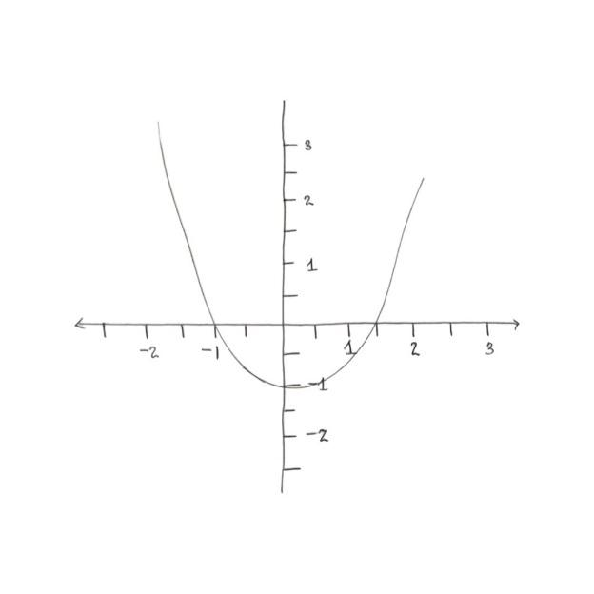

x-axis:2cm to 1 unit
y-axis:2cm to 1 unit

